


Scope and Storyboard for Aviva MI User Front End

Aviva Team, Manchester

By Gareth Levingston

Table of Contents

1. Document Revision History 2
1.1. Document Location 2
1.2. Revision History 2
1.3. Reviewed by 2
1.4. Approvals (please complete ‘name’ column on first draft) 2
1.5. Distribution 2
2. Summary of Scope 3
3. Screen design 3
4. Workflow 3
5. Navigation 3
5.1. Where will the Flow be launched from 3
5.2. Where should the Flow return to 3
6. SQL Tables 3
6.1. Table 3
6.2. Lookup 3
6.3. Field 3
7. Stored Procedures 3
7.1. Fetch 3
7.2. Save 3
8. Document Templates 3
9. Javascript 3

Document Revision History

Document Location
Full File Path

Revision History
Version Number | Revision Date | Summary of Changes | Changes marked | Author
1.0 | 13/06/2012 | First issue | n/a | GQL
2.0 | 14/06/2012 | Amendments including new fields following review to include litigation management:  - ‘Claimant Solicitor Location’- page 1 of MI  - ‘Details’ – page 3 of MI | Yes | LCZ
3.0 | 15/06/2012 | Amendments including VEW feedback | Yes | LCZ
4.0 | 18/06/2012 | Amendments including VEW feedback | Yes | LCZ

Reviewed by
Name | Signature | Title | Date of Issue | Version
Lisa Williams |  | Project Manager
Andrea Brown |  | Test Analyst

Approvals (please complete ‘name’ column on first draft)
Name | Signature or  Date of Approval Email | Title | Date of Issue | Version
Vivienne Williams
Mark Wheeler

Distribution
Name | Title | Date of Issue | Version

Summary of Scope

This scope describes the current MI requirement for Aviva as a client for Disease work types in terms of Field Set with any required pick lists and subsequent data structure changes to accommodate the complete field set.

Screen design

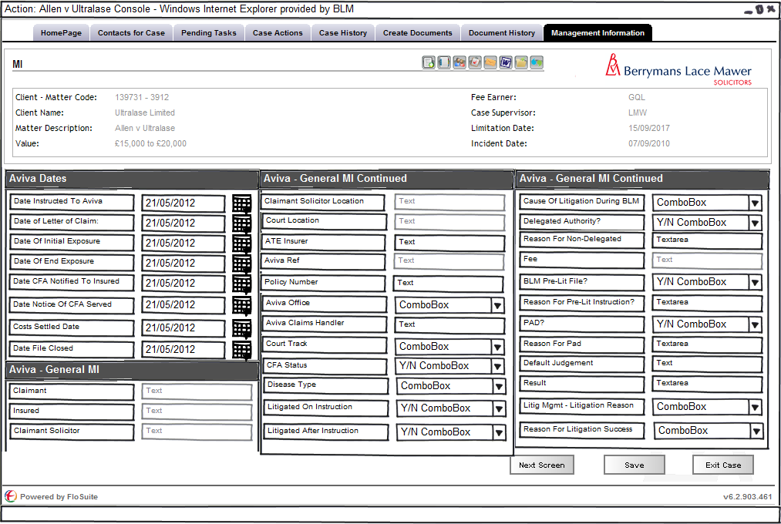
Figure 3 - Aviva Mi Screen 1

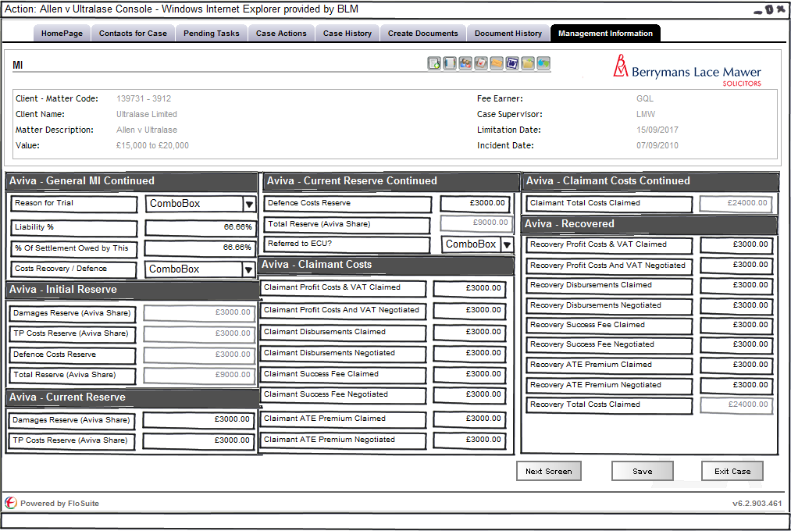
Figure 3 - Aviva Mi Screen 2

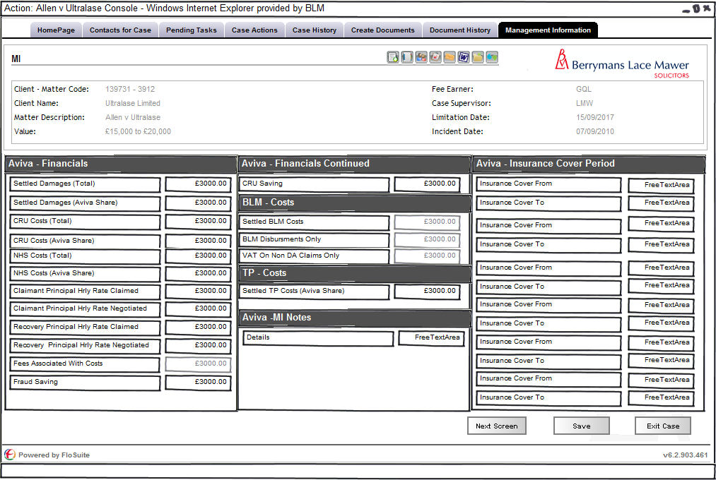
Figure 3 - Aviva Mi Screen 3

The above three diagrams show the screen layout designs for the Allianz MI based on the following data provided by the MI team:

Field Name | Format | Expert Field? | Existing MI Field? | Read Only? | Notes / Database Fields
Claimant | Text | No | Yes | No | Same as Aviva Main
Insured | Text | No | Yes | No | Same as Aviva Main
Aviva Ref | Text | No | Yes | No | Same as Aviva Main MI Field (Claim Number)
Aviva Office | Picklist | Yes | Yes | Yes | Read Only from Aderant - [_HBM_Client_Usr_Data].[Client_Location]
Aviva Claims Handler | Text | No | Yes | No | Same as Aviva Main
Default Judgement | Text | No | Yes | No | Same as Aviva Main
Date Liability Agreed (Pre Lit Only) | Date | No | Yes | No | Same as Aviva Main
Disease Type | Picklist | Yes | Yes | No | Read Write to Aderant - Picklist on Separate Tab - [_HBM_Matter_Usr_Data].[NUD_Disease_Type]
Litigated On Instruction | Yes / No | No | No | No | New field?
Litigated After Instruction | Yes / No | No | No | No | New field?
Cause Of Litigation During BLM Handling | Picklist | No | No | No | New field? - Picklist on Separate Tab
Delegated Authority? | Yes / No | Yes | Yes | No | Read Write to Aderant - [_HBM_Matter_Usr_Data].[Delegated_Authority]
Fee | Text | Yes | Yes | Yes | Read Only from Aderant - SQL to be Provided
Reason For Non-Delegated Authority | Free Text | Yes | Yes | No | Read Write to Aderant - [_HBM_Matter_Usr_Data].[NUD_Rsn_For_Non_Del]
BLM Pre-Lit File? | Yes / No | Yes | Yes | No | Read Write to Aderant - [_HBM_Matter_Usr_Data].[NUD_Pre_Lit_BLM_File]
Reason For Pre-Lit Instruction? | Free Text | Yes | Yes | No | Read Write to Aderant - [_HBM_Matter_Usr_Data].[NUD_Rsn_Prelit_Instr]
PAD? | Yes / No | No | Yes | No | Can [Case].[CaseDetails_PAD]
Reason For Pad | Free Text | No | Yes | No | ManagementInformation_ReasonForPADText
Policy Number | Text | No | Yes | No | Same as Aviva Main
Date LOC | Date | No | Yes | No | KeyDate: Code RECLOC
Date Instructed To Aviva | Date | Yes | Yes | No | Read Write to Aderant - [_HBM_Matter_Usr_Data].[Date_Instructed]
Date File Closed | Date | Yes | Yes | Yes | Read Only from Aderant - SQL to be provided (Final Bill Date)
Result | Free Text | No | No | No | New field?
Reason For Litigation Sucesses | Picklist | No | No | No | New field? - Picklist on Separate Tab
Reason For Trial | Picklist | No | Yes | No | ManagementInformation_TrialReasn - Picklist on Separate Tab
Court Location | Text | No | Yes | No | FloCase Contact
Court Track | Picklist | No | Yes | No | Is the field CaseDetails_CourtTrack the standard track required by all cases - if so then new field - picklist on separate tab - [_HBM_Matter_Usr_Data].[NUD_Court_Track]
Insurance Cover Period | Free Text | Yes | Yes | No | Read Write to Aderant - [_HBM_Matter_Usr_Data].[NUD_Ins_Cover_Period]
Date Of Initial Exposure | Date | Yes | Yes | No | Read Write to Aderant - [_HBM_Matter_Usr_Data].[NUD_Date_Init_Expos]
Date Of End Exposure | Date | No | Yes | No | KeyDate: Code ExpDteTo
Initial Total Reserve (Aviva Share) | Money | No | Yes | Yes | Read Only: Sum of Rows 33:35 writing to FinancialReserve_Total (History?)
Initial Damages Reserve (Aviva Share) | Money | No | Yes | No | Same as QBE
Initial TP Costs Reserve (Aviva Share) | Money | No | Yes | No | Same as QBE
Initial Defence Costs Reserve | Money | No | Yes | No | Same as QBE
Settled Damages (Total) | Money | No | Yes | No | TBC
Settled Damages (Aviva Share) | Money | No | Yes | No | [Financial].[Financial_DamagesPaid]
CRU Costs (Aviva Share) | Money | No | Yes | No | [Financial].[Financial_CRUValue]
NHS Costs (Aviva Share) | Money | No | Yes | No | [Financial].[Financial_NHSVal]
Settled BLM Costs | Money | Yes | Yes | Yes | Read Only from Aderant - SQL to be provided (Costs Billed)
BLM Disbursments Only | Money | Yes | Yes | Yes | Read Only from Aderant - SQL to be provided (Disbs Billed)
VAT On Non DA Claims Only | Money | Yes | Yes | Yes | Read Only from Aderant - SQL to be provided (VAT Billed)
Settled TP Costs (Aviva Share) | Money | No | Yes | No | Financial_CSCostsPaid
Liability % | Percent | No | Yes | No | Financial_LiabilityPercent
% Of Settlement Owed by This Client | Percent | No | No | No | New field?
Claimant Solicitor | Text | No | Yes | No | Same as Aviva Main
Claimant Solicitor Location | Text | No | Yes | TBC | FloCase Contact
CFA Status | Yes / No | No | Yes | No | ManagementInformation_CFAIndicator
Date CFA Notified To Insured | Date | No | No | No | New Field?
Date Notice Of CFA Served | Date | No | No | No | New Field?
Costs Recovery / Defence | Picklist | No | No | No | New field?
Claimant Total Costs Claimed | Money | No | Yes | Yes | Read Only field summing rows 51:58 writing to Costs_PTotalCSCostsPaid
Claimant Profit Costs & VAT Claimed | Money | No | Yes | No | Costs_PCSCostsClaimed
Claimant Profit Costs And VAT Negotiated | Money | No | Yes | No | Costs_PCSCostsPaid
Claimant Disbursements Claimed | Money | No | Yes | No | Costs_PCSDisbClaimed
Claimant Disbursements Negotiated | Money | No | Yes | No | Costs_PCSDisbPaid
Claimant Success Fee Claimed | Money | No | Yes | No | Costs_PSuccessFeeClmd
Claimant Success Fee Negotiated | Money | No | Yes | No | Costs_PSuccessFeePaid
Claimant ATE Premium Claimed | Money | No | Yes | No | Costs_PTPATEClmd
Claimant ATE Premium Negotiated | Money | No | Yes | No | Costs_PATEPremiumPaid
Recovery Total Costs Claimed | Money | No | Yes | Yes | Read Only field summing rows 60:67 writing to Costs_RTotalCSCostsRCVD
Recovery Profit Costs & VAT Claimed | Money | No | Yes | No | Costs_RCSCostsClaimed
Recovery Profit Costs And VAT Negotiated | Money | No | Yes | No | Costs_RCSCostsRcvd
Recovery Disbursements Claimed | Money | No | Yes | No | Costs_RCSDisbClaimed
Recovery Disbursements Negotiated | Money | No | Yes | No | Costs_RCSDisbRcvd
Recovery Success Fee Claimed | Money | No | Yes | No | Costs_RSuccessFeeClmd
Recovery Success Fee Negotiated | Money | No | Yes | No | Costs_RSuccessFeeRcvd
Recovery ATE Premium Claimed | Money | No | Yes | No | Costs_RTPATEClmd
Recovery ATE Premium Negotiated | Money | No | Yes | No | Costs_RATEPremiumRcvd
ATE Insurer | Text | No | No | No | New field?
Claimant Principal Hrly Rate Claimed | Money | No | Yes | No | Costs_PHourlyRateClaimed
Claimant Principal Hrly Rate Negotiated | Money | No | Yes | No | Costs_PCSHourlyRatePaid
Recovery Principal Hrly Rate Claimed | Money | No | Yes | No | Costs_RHourlyRateRcvd
Recovery Principal Hrly Rate Negotiated | Money | No | Yes | No | Costs_RCSHourlyRateRcvd
Fees Associated With Costs | Money | Yes | Yes | Yes | Read Only from Aderant - SQL to be provided (Time Billed in Costs Team)
Costs Settled Date | Date | No | Yes | No | KeyDate: Code CstSttlDte (To calc Days To Settle Costs)
Fraud Saving | Money | No | Yes | No | Financial_FraudSaving
CRU Saving | Money | No | Yes | No | Financial_CRUSaving
Referred to ECU? | Combobox – Yes No option | No | No | No | TBC
Insurance Cover From | Free Text Area | No | No | No | TBC
Insurance Cover To | Area Text Area | No | No | No | TBC
Details | Free Text | No | Yes | No | ManagementInformation_MINotes
Litig Mgmt – Litigation Reason | ComboBox | No | No | No | Values include:  Claimant's solicitor conduct  Delay by Aviva case handler  Delay due to multi parties  Delay by insured  Limitation  Non litigated  Quantum dispute  Unrealistic assessment by Aviva  Valid denial

This filed set will be defined for the following Group Code:
- AV-D

Workflow

The following triggers with in the natural flow of a Matter should prompt the user to review the MI on that matter these are as follows:
- Settlement
- PLEASE ADD MORE IF REQUIRED

SQL Tables modifications

Lookup

The following new look ups are required
- Disease Type
  - A1 - Mesothelioma
  - A2 - Pleural plaques
  - A3 - Pleural thickening
  - A4 - Asbestosis
  - A5 - Lung Cancer
  - A6 - Asthma
  - A7 - Rhinitis
  - A8 - Silicosis
  - A9 - Sick building syndrome
  - B10 - WRULD - factory
  - B11 - WRULD typing
  - B12 - Back - cumulative
  - B13 - Back - non cumulative
  - B14 - Fibromyalgia / chronic pain
  - B15 - Knee Cumulative
  - C16 - VWF / HAVS
  - C17 - CTS only
  - C18 - Whole body vibration
  - D19 - NIHL
  - D20 - Tinnitus only
  - D21 - Acoustic shock
  - E22 - Work overload
  - E23 - Bullying / harassment
  - E24 - Work overload & bullying / harassment
  - F25 - Respiratory illness
  - F26 - Exacerbation of respiratiry illness
  - F27 - Cardiovascular
  - F28 - Cancer
  - G29 - Power lines
  - G30 - Mobile phones
  - G31 - Electrical applications
  - H32 - Anthrax
  - H33 - Brucellosis
  - H34 - Leptospirosis (Weils disease)
  - I35 - Carbon monoxide
  - I36 - Deep Vein Thrombosis
  - I37 - Dermatitis
  - I38 - Food poisoning
  - I39 - Legionnaires disease
  - I40 - Other - please specify
  - I41 - Toxic mold
- Litig Mgmt – Litigation Reason
  - Claimant’s solicitor conduct
  - Delay by Aviva case handler
  - Delay due to multie parties
  - Delay to insured
  - Limitation
  - Non litigated
  - Quantum dispute
  - Unrealistic assessment by Avivia
  - Valid denial
- Reason For Litigation Sucesses
  - Breach
  - Causation
  - Limitation, Breach
  - Procedural Cover

- Court Track
  - PRE – Pre-Litigation
  - FAS – Fast Track
  - MUL – Multi Track
- Costs Recovery Defence
  - Recovery
  - Defence
- Cause Of Litigation During BLM Handling
  - Liability In Dispute
  - Insufficient Evidence to Take Pre-Lit Decision on Liability or Quantum
  - Failure to Take Pre-Lit Decision on Liability or Quantum
  - HSE Prosecution
  - Quantum in Dispute
  - Policy Cover Dispute
  - Precedent Setting Issue
  - Inquest
  - Limitation
  - Costs / Conduct Dispute
  - Infant Approval
  - Recovery Action
- Reason For Trial
  - Libiability in Dispute
  - Quantum in Dispute
  - Limitation
  - Policy Cover Dispute
  - Costs / Conduct Dispute
  - Recovery Action
  - Precedent Setting Issue
  - /tmp/lo/0000.doc

